CoCo Switchboard Installation

# Overview

Congratulations! You are about to become a Color Computer keyboard restorer. To successfully restore your failed keyboard membrane, I want to recommend some tips that I learned the hard way.

Key points:

* Work on a well-lit, flat surface with plenty of space.
* Get some plastic cups to hold your keyboard parts, like springs and screws.
* Get a couple of supports (like plywood or books) to prop up your keyboard while you work on it.
* A Philips screwdriver that fits small screws. No power tools.
* Take your time.
* Use the backward-first technique for inserting screws (see below).

GitHub Materials: https://github.com/mrojas36/CoCoSwitchboard

# Working on 40-year-old Plastic

**IMPORTANT:** The chassis of your keyboard is plastic. Ancient plastic. It is delicate and you can ruin it if you are not careful. The most important thing to understand is that when your keyboard was assembled, screws were driven into the plastic *creating the grooves* that your screws now sit in. **It is important that your new screws use the same grooves.** You do NOT want to create new ones. Two sets of grooves will just create a stripped-out hole and the screw will not hold anymore.

So how do you make sure your screw goes into the existing grooves?

Easy. Use the “backwards first” technique. Here is how it works.

1. Place screw into hole.
2. Using your screwdriver, slowly turn the screw backwards (counterclockwise) while applying gentle pressure.
3. While turning backwards, you will feel the screw drop and “click”. That is when you know your screw has realigned with the original grooves.
4. Now you can turn the screw clockwise and gently tighten until it stops. Do not over tighten.

You can use the screw holder that was shipped with the kit to practice. Once you get the hang of it, congratulations – you are a restoration master!

# Step 1 – Remove your keyboard

Open your Color Computer by removing the screws on the bottom of your case. There should be six screws on most machines. **Remember, the long screws will go in the back.** Place the case screws into one of your plastic cups for safe keeping.

Pull the flexible flat cable out of CN2 by pulling straight up. If it is stuck, try rocking it left and right until it pulls free. We now have your keyboard removed. Set your keyboard aside for the moment.

# Step 2 – Connect the Keyboard Adapter

You should test that only your membrane has failed. You can do that by connecting the keyboard adapter to your new switchboard and temporarily installing the assembly into your computer. Hold the board so you can see the pin header and press the connector in, making sure both rows of pins mate properly. **Note: if you have a CoCo 1 with a pin header style keyboard, see the errata in the back.**

# Step 3 – Test your Switchboard

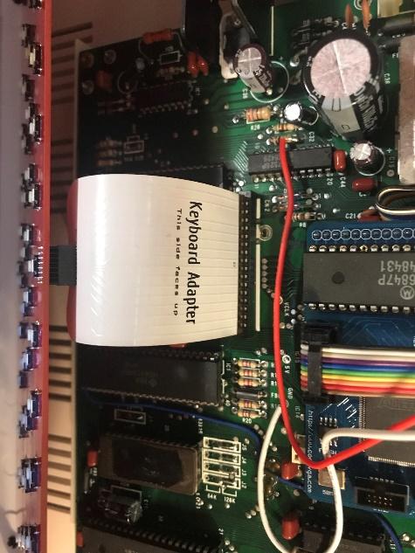Install the assembly into your computer with the top case off. Insert the keyboard adapter into connector CN2 on your motherboard, like this:

You can prop up the switchboard like this:

Power up your computer and press every key. Make sure you try the shift keys as well. Your switch board and keyboard adapter were tested in a real machine before it was shipped. If keys are not working, it is possible you have other damage that needs repaired.

Examples include:

* Failed PIA chip
* CN2 connector is bad or oxidized
* Trace damage on your motherboard

Resolve these issues before continuing.

If things look good, let’s swap it into your actual keyboard.

**IMPORTANT: If you are a Color Computer 1 or 3 owner, you can skip to step 5. If you are a Color Computer 2 owner, proceed to the next step.**

# Step 4 – Test fit Switchboard on your computer.

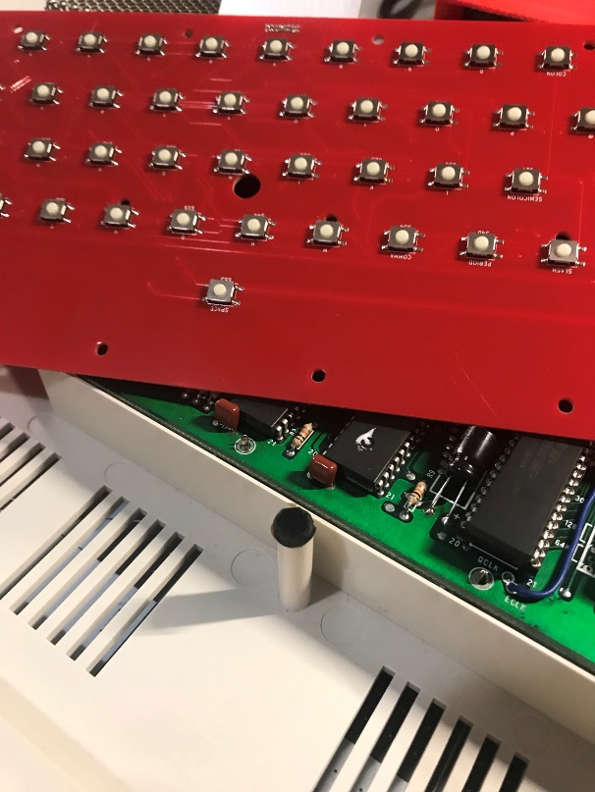Notice that the board has a hole in the center. This is meant to align with the middle support post in your computer. On a Color Computer 1 and Color Computer 3, the center support post will rest inside the cavity made by the hole and the spacer.

On a Color Computer 2, the **hole will be too small**. This is because there is a switch that will not allow the center hole to be larger. Because of this, you will need to trim down the diameter of the rubber support in the center post.

This rubber post will need trimmed.

You can trim it down from the top – taking a bit of rubber off the top but this will be irreversible. This means the support will be too short if you decide to put the old membrane back. Or you can trim the **diameter** like I did. This will be reversible – meaning the old membrane could be put back.

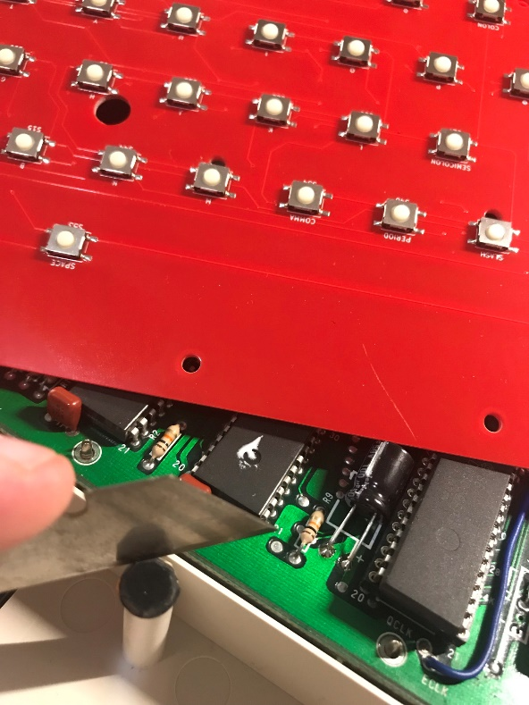

To change the diameter of the rubber support, take a razor blade and carefully trim around the post. Try to make little slices by holding the razor blade vertically and pressing down until you hit the plastic. Continue around the post until you have trimmed every side.

You should be able to fit the rubber part of the support into the hole when the diameter is small enough.

# Step 5 – Remove your Old Membrane

Get a pair of supports to prop up your keyboard like this:

The important thing is to make sure your keys can hang suspended and not depressed. You are now ready to remove the back plate. Color Computer 2 and Color Computer 3 will have 18 screws to remove. A Color Computer 1 has 20. Save your old screws in case you want to reverse this process.

Use a plastic cup or some other container to hold the screws.

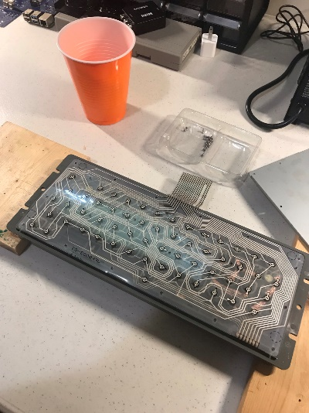Now carefully remove the back plate, exposing the keyboard membrane. **IMPORTANT:** If your keyboard has suffered liquid damage, it is possible that the back plate will have become glued to the membrane. Remove slowly and take care to pull it apart in a way that will NOT send your springs flying!

Set the back plate aside. You will not need the back plate or the membrane.

With the membrane exposed, carefully remove the membrane taking care to not lose your springs!

Set it aside as well.

With the membrane off, look closely and make sure you have all your springs. A Color Computer 1 has rubber domes instead of springs. Make note that the space bar has a different color spring because it needs a different level of force. If you take out your springs, make sure you put that different color spring back into the space bar key.

**TIP:** Now would be a great time to remove every spring and then wash your keyboard. If it has liquid damage, giving it a good clean will go a long way. Some people even get a keyboard puller (just google it) and remove every key, hand washing each one. Some even retrobrite the keys to remove the yellowing.

# Step 6 – Install the Spacer and Switchboard

The switches need to be positioned so they do not interfere with the travel of the keys. The spacer accomplishes this task. The spacer will arrive in two pieces. It can only be installed one way, but in the center of the spacer you will see a small round indentation. This will align with the hole in the center of the switchboard.

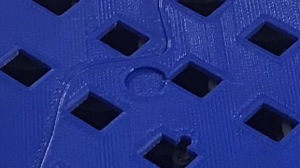

The spacer will also align with the two keyboard posts on each side of the board.

**Important:** You need to be careful when placing the spacer and switchboard on top of your keyboard. It is important that everything lines up nicely with your keys. Place the spacer down as centered as possible, then place the switch board on top, making sure the switches fit into the openings on the spacer.

When you think you have everything aligned, you can now begin the assembly.

To assemble the board, you will need to press down on the board, compressing the springs, and placing the screws into the board with your other hand. You should start in the center and work towards the edges of the keyboard.

You are now ready to begin inserting the **new screws** (provided in the kit) into the switchboard.

Take your time and do one screw at a time.

**You will have to use the screws provided in the kit.** Your original screws will be too short to go back in.

**Remember to use the “backwards first” technique!**

When you are installing the screws, make sure you are applying enough pressure to compress the springs. I used one hand to apply pressure and the other hand to put the screws in:

I worked my way from the center to the edges. Make sure you do not over-tighten the screws.

The hard part is now done!

# Step 7 – Install the keyboard back into your computer

Notice that the board has a hole in the center. This is meant to align with the middle support post in your computer. On a Color Computer 1 and Color Computer 3, the center support post will rest inside the cavity made by the hole and the spacer.

On a Color Computer 2, the **hole will be too small**. But you would have fixed this in step 4.

Set the keyboard back on its support posts and gently insert the keyboard adapter into the connector CN2.

Put your case screws back in.

Sit back and enjoy your handiwork. Nice work!

# New Spacer – Errata

The old spacer design had a few challenges. For one, it was 3D printed in two pieces making it hard to get properly aligned. The new spacer aims to resolve that by printing the spacer as a single piece. In addition, we added a few new holes in the spacer: one to allow the springs to pass through and another to give the membrane “nub” a place to rest without interfering with the key action.

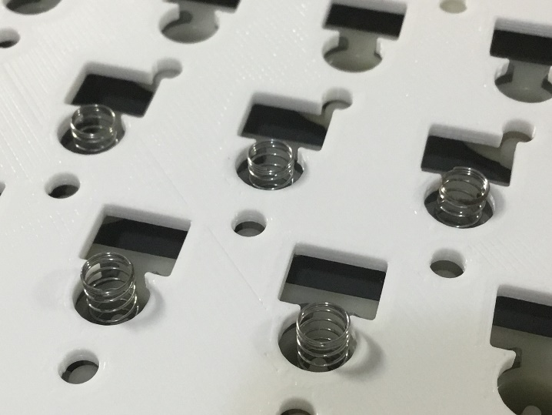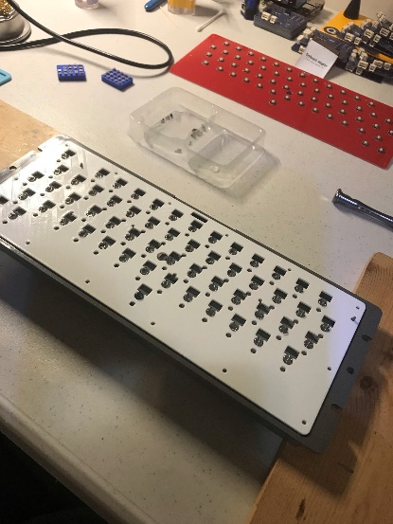

Hole for spring to pass through

Hole for “nub” to pass through

Using the new spacer is simple, however, here are a few tips:

* **Remove your springs before attempting to place the spacer**. The springs are in fact “springy” and if the hole of the spacer catches the spring they will go flying! I found removing the springs, placing them in a cup, then placing the spacer, and reinserting the springs works better.
* **Key sticking**. Sometimes the hole for the membrane “nub” has some PLA strings in it. These imperfections can sometimes catch the key and cause it to stick. Inspect the spacer before using. I suggest you try every key with the springs out and the spacer placed on top and held by hand. Hold the keyboard with the keys down and the spacer up. Now start pressing keys from the underside and look for sticking keys. You should be able to press the key and just let it drop back down.

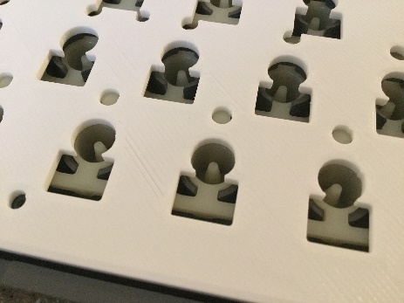Eliminating the sticking key is easy, just round out the “nub” hole with a razor blade until the key no longer sticks.

Take a razor blade and round the hole that is causing the key to stick

# CoCo 1 Pin Header Keyboards – Use Edge Adapter included

To attach the keyboard adapter to an older style CoCo1 keyboard header that has pins use the edge adapter board provided.

This adapter will convert the edge connector style adapter to a pin header style.

To install the adapter is it suggested **to attach the keyboard adapter first** into the slot of the edge adapter board. This will make it easier to insert into the CoCo pin headers. **Warning:** it is possible to tear the keyboard adapter if you use to too much force inserting the edge adapter into the CoCo. Make sure you only grasp the red adapter board when pushing it into the CoCo main board. After you have it attached, you can then attach the keyboard to the small 10-pin header.

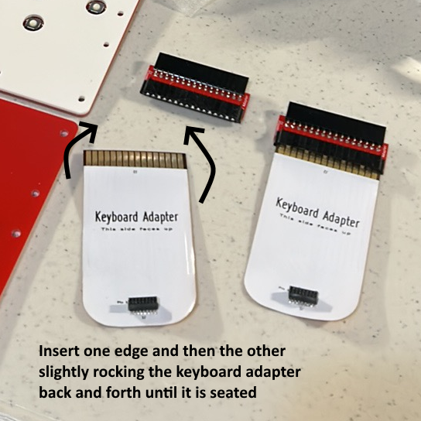

Here you can see we have attached the red edge adapter board to the keyboard adapter **before** trying to connect the edge adapter to the CoCo main board. The gold pads on the keyboard adapter will be a tight fit into the edge adapter. It is suggested you rock the keyboard adapter gently back and forth while pushing it into the edge adapter. It will go in about half way.

After the edge adapter is connected to the CoCo, then you can attach the keyboard.